### 

### Semester Two Examination, 2023

### Question/Answer booklet

# 12 SPECIALIST MATHEMATICS

## Section One:

## Calculator-free

|  |
| --- |
|  |

Your Name ________________________________

Your Teacher’s Name __________________________

## Time allowed for this section

Reading time before commencing work: five minutes

Working time: fifty minutes

## Materials required/recommended for this section

***To be provided by the supervisor***

This Question/Answer booklet

Formula sheet

***To be provided by the candidate***

Standard items: pens (blue/black preferred), pencils (including coloured), sharpener, correction fluid/tape, eraser, ruler, highlighters

Special items: nil

## Important note to candidates

No other items may be taken into the examination room. It is **your** responsibility to ensure that you do not have any unauthorised material. If you have any unauthorised material with you, hand it to the supervisor **before** reading any further.

|  |  |  |  |  |  |
| --- | --- | --- | --- | --- | --- |
| Question | Mark | Max | Question | Mark | Max |
| 1 |  | 9 | 5 |  | 9 |
| 2 |  | 7 | 6 |  | 8 |
| 3 |  | 8 |
| 4 |  | 9 |

**Structure of this paper**

|  |  |  |  |  |  |
| --- | --- | --- | --- | --- | --- |
| Section | Number of questions available | Number of questions to be answered | Working time (minutes) | Marks available | Percentage of examination |
| Section One:  Calculator-free | 6 | 6 | 50 | 50 | 34 |
| Section Two:  Calculator-assumed | 13 | 13 | 100 | 97 | 66 |
|  |  |  |  | **Total** | 100 |

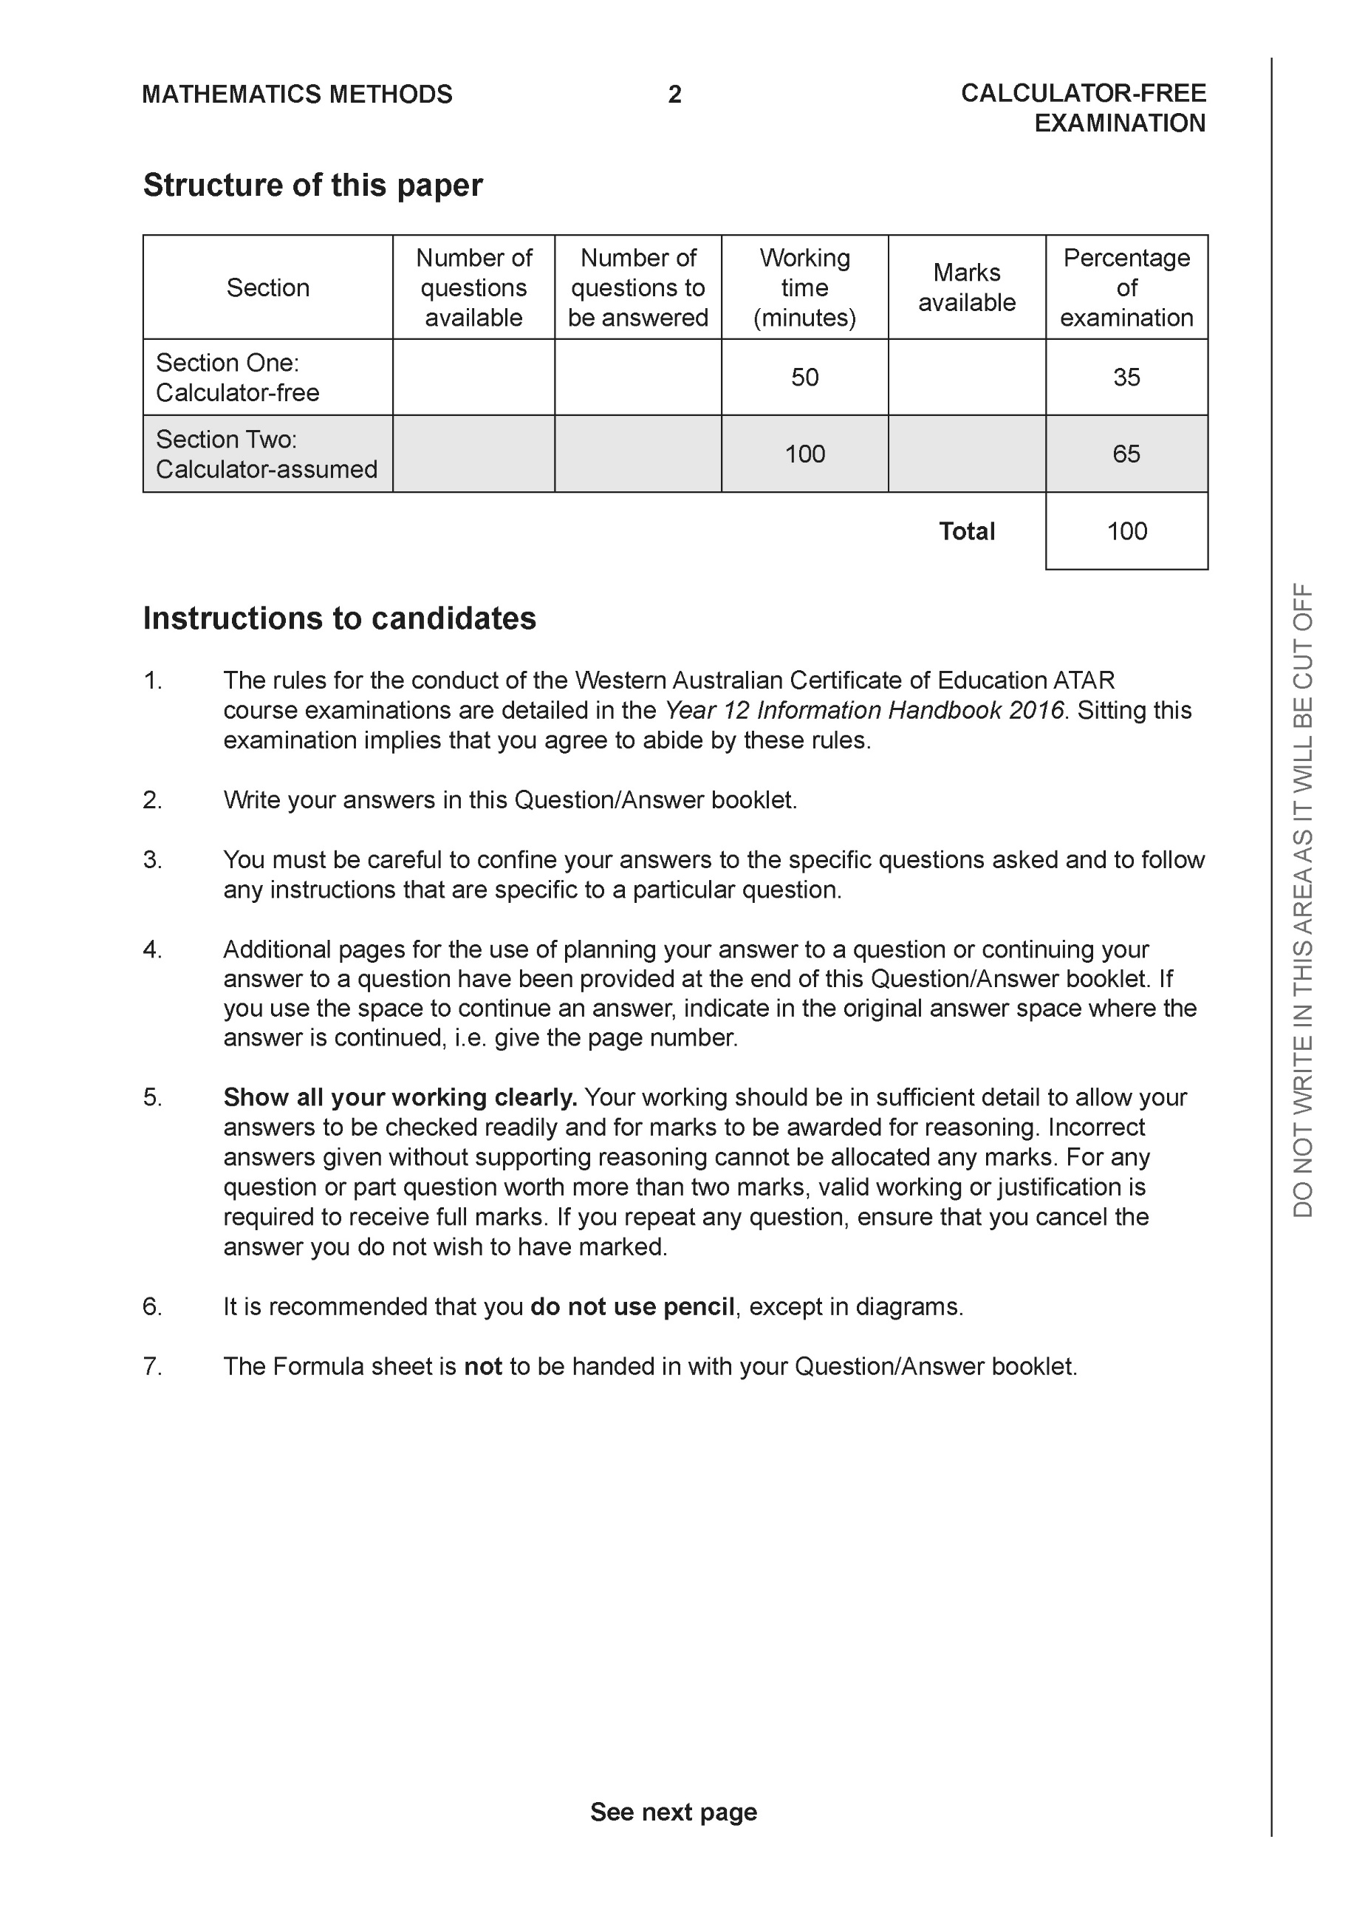

**Section One: Calculator-free (50 Marks)**

This section has **six (6)** questions. Answer **all** questions. Write your answers in the spaces provided.

Spare pages are included at the end of this booklet. They can be used for planning your responses and/or as additional space if required to continue an answer.

● Planning: If you use the spare pages for planning, indicate this clearly at the top of the page.

● Continuing an answer: If you need to use the space to continue an answer, indicate in the original answer space where the answer is continued, i.e. give the page number. Fill in the number of the question that you are continuing to answer at the top of the page.

Working time: 50 minutes.

**Question 1 (9 marks)**

Consider the functions  and .

1. Determine the natural domain and range of . (3 marks)

|  |
| --- |
| **c** |
|  |
| **Specific behaviours** |
| 🗸 states domain  🗸 identifies endpoints of y=-1&0 in the range  🗸 uses correct inequalities in excluded/included range |

1. Does  exist over the natural domain of ? Explain. (3 marks)

|  |
| --- |
| **c** |
|  |
| **Specific behaviours** |
| 🗸 states relevant domain and range  🗸 states does not exist  🗸 states clearly reason why |

1. State  and its natural domain. (3 marks)

|  |
| --- |
| **c** |
|  |
| **Specific behaviours** |
| 🗸 states rule simplified  🗸 states conditions for numerator  🗸 states domain for composite |

**Question 2 (7 marks)**

Determine the following integrals.

1. . (3 marks)

|  |
| --- |
| **c** |
|  |
| **Specific behaviours** |
| 🗸 uses an appropriate substitution which is stated  🗸 rearranges integral in terms of new variable  🗸 integrates and adds a constant |

1. . (4 marks)

|  |
| --- |
| **c** |
|  |
| **Specific behaviours** |
| 🗸 uses Pythagorean identity  🗸 rearranges integral into two parts  🗸 integrates  🗸 subs limiting values |

**Question 3 (8 marks)**

1. The function  can be expressed in the form  where are constants.

Determine the values of . (4 marks)

|  |
| --- |
| **c** |
|  |
| **Specific behaviours** |
| 🗸 sets up equation to solve for constants  🗸 solves for a  🗸 solves for b  🗸 solves for c |

1. Hence determine . (4 marks)

|  |
| --- |
| **c** |
|  |
| **Specific behaviours** |
| 🗸 multiplies by factor 2  🗸 integrates first term  🗸 integrates second term  🗸 adds a constant |

**Question 4 (9 marks)**

Consider a herd of 25 horses,  in an isolated habitat such that the growth rate after  years is given by .

1. By using separation of variables and partial fractions, derive  showing all working.

(5 marks)

|  |
| --- |
| **c** |
|  |
| **Specific behaviours** |
| 🗸 explains limit for N and hence no need for absolute value when integrating  🗸 separates variables  🗸 uses partial fractions and then shows integration  🗸 rearranges to give function with all constants solved |

Q4 continued

1. Determine the limiting value of the number of horses. (2 marks)

|  |
| --- |
| **c** |
| N=250 |
| **Specific behaviours** |
| 🗸 uses t approaching infinity  🗸 states limit |

1. Set up an equation, but do not solve, that will allow the time to be calculated where the growth rate is a maximum. (2 marks)

|  |
| --- |
| **c** |
|  |
| **Specific behaviours** |
| 🗸 selects half the limiting value for N  🗸 states equation for t |

**Question 5 (7 marks)**

A designer creates a heart-shaped pendant for Valentine’s Day shown on the right, using the function

<EFOFEX>

id:fxd{2ea7094e-ec83-4fe4-8952-d8890a69bc86}


FXData:

</EFOFEX>

For this equation becomes

$$2x^{2}-2xy+y^{2}-1=0$$

(a) Show that $\frac{dy}{dx}=\frac{2x-y}{x-y}$.  (3 marks)

|  |  |
| --- | --- |
| **Solution** | **Specific behaviours** |
| $$\frac{d}{dx}\left(2x^{2}-2xy+y^{2}-1\right)=\frac{d}{dx}\left(0\right)$$ $$4x-2y-2x\frac{dy}{dx}+2y\frac{dy}{dx}=0$$ $$\frac{dy}{dx}\left(2y-2x\right)=2y-4x$$ $$\frac{dy}{dx}=\frac{2y-4x}{2y-2x}=\frac{2x-y}{x-y}$$ | * Implicitly differentiates left hand side. * Takes out $\frac{dy}{dx}$ as common factor. * Rearranges to get required result. |

Q5 continued-

<EFOFEX>

id:fxd{b8923def-c0e2-4228-8fae-86914885a381}


FXData:

</EFOFEX>The jewellery plans to attached a small square shaped clasp to the pendant. One corner of the square will sit in the cusp on the curve at the point of contact. The situation is illustrated on the right.

(b) (i) Determine the coordinates of the point of contact. (1 mark)

|  |  |
| --- | --- |
| **Solution** | **Specific behaviours** |
| $$Substitute x=0$$ $$y^{2}-1=0⇒point is (0, 1)$$ | * Determines coordinates of point of contact. |

(ii) At the point of contact, will the gradient of the heart match that of the clasp?  
 Justify your answer. (3 marks)

|  |  |
| --- | --- |
| **Solution** | **Specific behaviours** |
|  | * Determines gradient of tangent to the curve at $(0,1)$. * Determines angle of inclination. * Explains why the clasp will meet at the point of contact. |

**Question 6 (8 marks)**

Let $v=1+\sqrt{3}i$.

(a) Determine the three cube roots of $v$. (3 marks)

|  |
| --- |
| Solution |
| $$v=2\operatorname{cis}\left(\frac{π}{3}\right) \\ v^{\frac{1}{3}}=2^{\frac{1}{3}}\operatorname{cis}\left(\frac{π}{9}+\frac{2nπ}{3}\right)$$ Hence the cube roots are: $$\sqrt[3]{2}\operatorname{cis}\left(\frac{7π}{9}\right), \sqrt[3]{2}\operatorname{cis}\left(\frac{π}{9}\right), \sqrt[3]{2}\operatorname{cis}\left(-\frac{5π}{9}\right)$$ |
| Specific behaviours |
| ✓ writes $v$ in polar form  ü obtains one correct root  ü correctly states all roots |

(b) Consider the polynomial $P\left(z\right)=z^{4}-8z^{3}+kz^{2}-46z+44$, where $k$ is a real constant.  
  
Given that $P\left(v\right)=0$, solve the equation $P\left(z\right)=0$. (5 marks)

|  |
| --- |
| Solution |
| $P$ has real coefficients and so $v$ and $\overline{v}$ are factors: $$(z-v)(z-\overline{v})=(z-1+\sqrt{3}i)(z-1-\sqrt{3}i) \\ =z^{2}-2z+4$$ Hence $z^{4}-8z^{3}+kz^{2}-46z+44=\left(z^{2}-2z+4\right)\left(z^{2}+az+11\right)$, where $a$ is a real constant.  Comparing coefficients of $z$ then $-46=4a-22⇒a=-6$.  Zeros of second quadratic factor: $$z^{2}-6z+11=0 \\ {\left(z-3\right)}^{2}=-2=2i^{2} \\ z=3±\sqrt{2}i$$ Solutions are $z=1±\sqrt{3}i, =3±\sqrt{2}i$.  *Note that it is possible to deduce $k=27$, but this is not required.* |
| Specific behaviours |
| ✓ indicates $P\left(\overline{v}\right)=0$ or $z-\overline{v}$ is a factor of $P$ ü correctly determines quadratic factor of  ✓ determines second quadratic factor  ü obtains a zero from second quadratic factor  ü states all solutions |

Working out space

**Working out space**

**Working out space.**